10. PROPERTIES OF PURE SUBSTANCES
PURE SUBSTANCE: A substance is said to be pure substance which has same chemical composition throughout its mass. Pure substance can be more than one component and/or phase. E.g. Air (21% O2 & 79% N2), Container filled with water or water and its vapour, Container filled with water (Solid, Liquid, Vapour), Etc…
SATURATION POINT: It’s a point where phase change just begins.
SENSIBLE HEAT TRANSFER: Heat transfer without phase change. Temperature changes.
LATENT HEAT TRANSFER: the heat or energy that is absorbed or released during a phase change of a substance. Temperature remains constant because heat supplied or rejected are used in bond formation or braking.
PHASE TRANSFORMATION OF PURE SUBSTANCE (H2O):
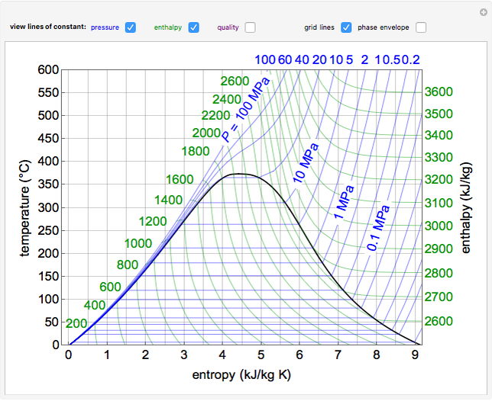 |  | 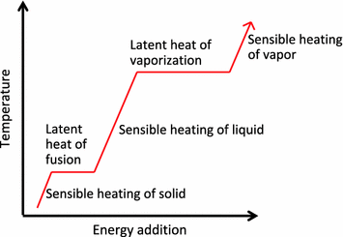
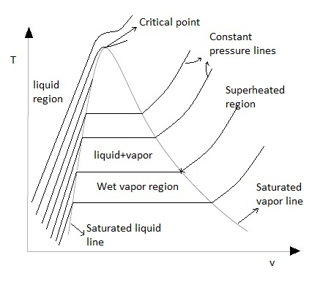 | 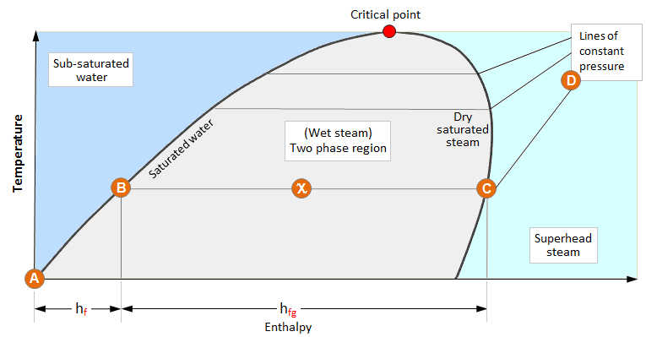
In phase change process Pressure and Temperature remains constant.
LATENT HEAT OR ENTHALPY OF EVAPORATION/ VAPORISATION/ CONDENSATION: $h_{fg}=h_{g}-h_{f}$  RELATION BETWEEN PRESSURE AND TEMPERATURE: If Pressure increase Boiling temperature also increases and vice versa.  CRITICAL POINT: It’s point where saturated liquid line, saturated vapour line meet. At critical point,  $$h_{fg}=0=h_{g}-h_{f}$$ $$P_{cr}=221.21 bar$$  $$v_{cr}=0.00317 {m^{3}}/{kg}$$ $$T_{cr}=374.15 °C$$  Liquid directly converts to vapours. There is no constant temperature vaporisation. ${\left({dT}/{dS}\right)}_{cr}=0$ | 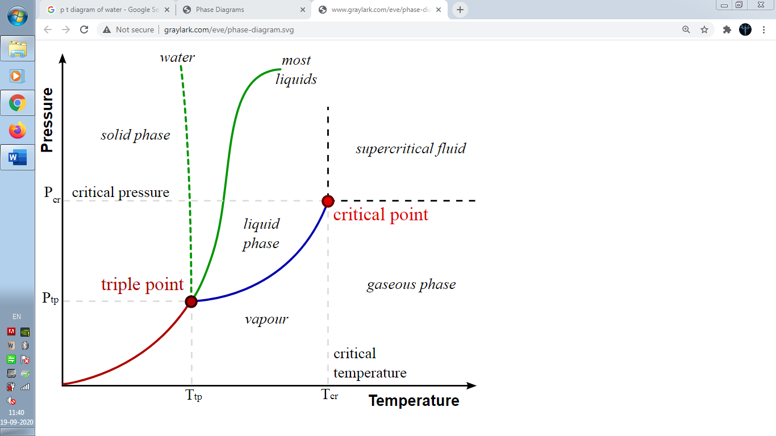
P-V DIAGRAM FOR PURE SUBSTANCE (H2O):  Slop of liquid line is almost constant because liquids are incompressible. Same way vapours are compressible so slope of line is significant for vapour line. | 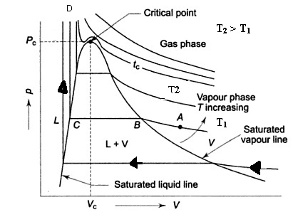  H-S (MOLLIER) DIAGRAM FOR PURE SUBSTANCE (H2O):  Slope of constant pressure line,  $${\left(\frac{dh}{ds}\right)}_{P=c}=T(From TdS 2nd equation)$$  During phase change, slope = $T$ = Constant.
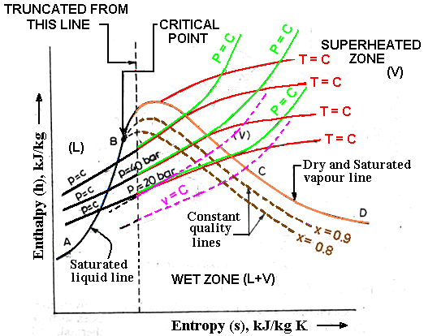
In super-heated region, enthalpy & slope increases with Temp.

In PV diagram, If pressure increase
$$v<v_{cr}⇒Vapour + Liquid converts to vapour$$ | $$v>v_{cr}⇒Vapour converts to Superheated vapour$$
At triple point, According to Gibb’s Phase Rule, Degree of freedom, $F_{TP}=0$.
PHASE TRANSFORMATION PROCESSES
$L⟶V⇒$ Vaporisation | $S⟶L⇒$ Melting or Fusion | $S⟶V⇒$ Sublimation
$V⟶L⇒$ Condensation | $L⟶S⇒$ Freezing or Solidification | $V⟶S⇒$ Deposition
In PT Diagram of pure substance (H2O),
General Substance ($Slope,\left[{dP}/{dT}\right]>0$) |  | Water ($Slope,\left[{dP}/{dT}\right]<0$)
$$Melting⇒Expands$$ | $$Freezing⇒Contracts$$ | $$Melting⇒Contracts$$ | $$Freezing⇒Expands$$
CLAPEYRON EQUATION: Draw PT diagram and get slope experimentally to find latent heat during phase change.
Using 4th Maxwell Equation, | $${\left[\frac{∂P}{∂T}\right]}_{v}={\left[\frac{∂s}{∂v}\right]}_{T}⇒Slope of PT=\frac{dP}{dT}=\frac{ds}{dv}=\frac{s_{fg}}{v_{fg}}=\frac{LH}{v_{fg}T_{sat}}$$
CLAUSIUS-CLAPEYRON EQUATION: Draw PT diagram and get slope experimentally to find latent heat.
Put below mentioned assumption of Clausius in Clapeyron Eq.,  $$v_{g}≫≫v_{f}$$ $$v_{g}=v_{ideal}={RT}/P$$ | $$\frac{dP}{dT}=\frac{LH}{v_{fg}T_{sat}}=\frac{LH}{v_{g}T_{sat}}=\frac{\left(LH\right)P }{RT_{sat}^{2}}$$

SUB COOLED LIQUID: $T_{liq.}<T_{sat.}$ | DEGREE OF SUB COOLING: $T_{sat.}-T_{liq.}$
SATURATED MIXTURE OR WET STEAM: $T_{sat.}=T_{liq.}=T_{vap.}$
SUPERHEATED VAPOURS: $T_{liq.}>T_{sat.}$ | DEGREE OF SUPERHEATING: $T_{liq.}-T_{sat.}$
PROPERTIES OF SATURATED MIXTURE:
Dryness Fraction or Quality of Steam ($x$):  $x$ Represents Mass Fraction of Vapour.$\left(0≤x≤1\right)$ | $$x=\frac{m_{vap.}}{m_{tot.}}=\frac{m_{vap.}}{m_{vap.}+m_{liq.}}$$
Wetness Fraction or Liquid Fraction:  It Represents Mass Fraction of Liquid. | $$Wetness Fraction=1-x=\frac{m_{liq.}}{m_{tot.}}$$
Specific Volume of Saturated Mixture/ Wet Steam:  $$v=v_{f}+xv_{fg}$$ | $$∵V_{tot.}=V_{L}+V_{V}⇒m_{tot.}v_{tot.}=m_{L}v_{L}+{m_{V}v}_{V}$$  $$∵v_{tot.}=xv_{V}+\left(1-x\right)v_{L}$$
Specific Enthalpy of Saturated Mixture/ Wet Steam: $h=h_{f}+xh_{fg}$
Specific Entropy of Saturated Mixture/ Wet Steam: $s=s_{f}+xs_{fg}$
Specific Internal Energy of Saturated Mixture/ Wet Steam: $u=u_{f}+xu_{fg}$
PROPERTIES OF DRY SATURATED STEAM:
Specific Enthalpy of Dry Saturated Steam: $h_{g}=h_{f}+h_{fg}=h_{f}+LH$
Specific Volume of Dry Saturated Steam: $v_{g}=v_{f}+v_{fg}$
Change of Entropy During Phase Change Process: $s_{fg}={\left[Q/T\right]}_{rev}={LT}/{T_{sat.}}$
Specific Entropy of Dry Saturated Steam:$s_{g}=s_{f}+s_{fg}$
Specific Internal Energy of Dry Saturated Steam: $u_{g}=u_{f}+u_{fg}$
PROPERTIES OF SUPERHEATED STEAM: Superheated Vapour can be treated as ideal gas.
Specific Enthalpy of Superheated Vapour: $h_{sup.}=h_{g}+∆h=h_{g}+{\left[C_{P}\right]}_{ vap}(T_{sup.}-T_{sat.})$
Specific Volume of Superheated Vapour: ${v_{sup.}}/{T_{sup.}}={v_{g}}/{T_{sat.}}$
Specific Entropy of Superheated Vapour:$s_{sup.}=s_{g}+∆s=s_{g}+{\left[C_{P}\right]}_{ vap}\ln\left[{T_{sup.}}/{T_{sat.}}\right] (From main 3 eq.)$
Specific Internal Energy of Superheated Vapour: $u_{sup.}=h_{sup.}-Pv_{sup.} (∵h=u+Pv)$
GIBB’S PHASE RULE: $P+F=C+2$
$P=$ No. of Phases | $F=$ Degree of Freedom | $C=$ No. of Components
DEGREE OF FREEDOM ($F$): The number of properties required to identify the state of system.
For Simple Compressible System/ Pure Substance: $P=1,C=1⇒F=2$

DEGREE OF FREEDOM AT VARIOUS POINTS:
DOF For Saturated Liquid: $P=2,C=1⇒F=1 (Either P or T)$
DOF For Saturated Vapour: $P=2,C=1⇒F=1 (Either P or T)$
DOF For Superheated Vapour: $P=1,C=1⇒F=2 \left(any 2 property\right)$
DOF For Saturated Mixture: $P=2,C=1⇒F=1 \left(Either P or T\right) It^{'}s exceptional case. In actual F=2$
DOF For Saturated Triple Point: $P=3,C=1⇒F=0$
THROTTLING OF WET STEAM: It’s Isenthalpic & Adiabatic irreversible process. Due to throttling pressure and temperature after process decrease & Entropy increases due to irreversibility. Hence, due to friction heat generates and dryness fraction of wet steam increases. (TS Diagram Representation)
THROTTLING OF DRY SATURATED STEAM: Due to throttling pressure and temperature after process decrease & Entropy increases due to irreversibility. Hence, due to friction heat generates and dry saturated steam molecules absorbs generated head and steam becomes Superheated Steam. (TS Diagram Representation)
EVALUATION OF CONDITION OF STEAM FROM VARIOUS PROPERTY:
- Use $T_{liq.}\& T_{sat.}$ Conditions.
- Use $v$ values to compare with $v_{g},v_{f},v_{fg}$.
STEAM TABLES:
- Saturated Water-Temp. Table
$$T$$ | $$P_{sat.}$$ | $$v_{f}$$ | $$v_{g}$$ | $$v_{fg}$$ | $$h_{f}$$ | $$h_{g}$$ | $$h_{fg}$$ | $$u_{f}$$ | $$u_{g}$$ | $$u_{fg}$$ | $$s_{f}$$ | $$s_{g}$$ | $$s_{fg}$$
- Saturated Water-Pressure Table
$$P$$ | $$T_{sat.}$$ | $$v_{f}$$ | $$v_{g}$$ | $$v_{fg}$$ | $$h_{f}$$ | $$h_{g}$$ | $$h_{fg}$$ | $$u_{f}$$ | $$u_{g}$$ | $$u_{fg}$$ | $$s_{f}$$ | $$s_{g}$$ | $$s_{fg}$$
- Superheated Water Table
$$P$$
$$T$$ | $$v$$ | $$h$$ | $$u$$ | $$s$$
We can corelate DOF with steam tables. The same thing is highlighted with bolt font (No. of property).
CHANGE IN ENTHALPY FOR SOLIDS & LIQUIDS:
$$h=u+Pv⇒dh=du+d\left(Pv\right)=du=CdT=f(T)$$ | $$for solid and liquids, dP=dv=0$$
REFERENCE POINT FOR CALCULATION:
CALCULATION OF ENTHALPY FROM REFERENCE POINT:
$$Reference temperature= 0 °C=273 K \& For soilds and liquids dh=du=CdT, C_{water}=4.187 {KJ}/{kg K}$$
CALCULATION OF ENTROPY FROM REFERENCE POINT:
$$Reference Temp.= 0 °C=273 K \& For soilds and liquids ∆s=C\ln\left({T_{f}}/{T_{i}}\right), C_{water}=4.187 {KJ}/{kg K}$$

